

Activity - Fund's monthly returns analysis

**Tasks**

Select the Excel file returns.xls:

1. Use data analysis in Excel (you might need to load the add-ins Analysis ToolPack) to estimate the **correlation matrix** of the funds’ returns. What insight do you get from the same?
2. Draw a **scatter plot** of the returns for: funds 1 and 7, funds 9 and 10, funds 7 and 8. Are the charts confirming the indications obtained from the correlation matrix?
3. Create a **histogram** for the returns of funds 1, 2, 3, 4, and 5 (use the same number of bins). Discuss the shape of each histogram. Can you guess what the mean, median, and mode values are? Can you identify funds where the outliers’ impact is more relevant? You might use the Excel function skew() to support your findings.
4. Use data analysis to calculate a **linear regression** of each fund’s returns (focus on the first 5 funds) vs. explanatory variables (available in the file). Analyse their impact in each case.
5. Report and discuss the results in class.

**Task 1**

From your private folder, open the spreadsheet ‘**returns**’ and select the worksheet ‘**funds**’:

Use data analysis in Excel (you might need to load the add-ins Analysis ToolPack) to estimate the **correlation matrix** of the funds’ returns.

The correlation structure between the funds in the sample is visualised. What insight do you get from the same?

What are the funds which show the highest level of correlation?

Which is the most decorrelating fund within the sample of funds?

**Task 2**

Draw a **scatter plot** of the returns for: funds 1 and 7, funds 9 and 10, funds 7 and 8.

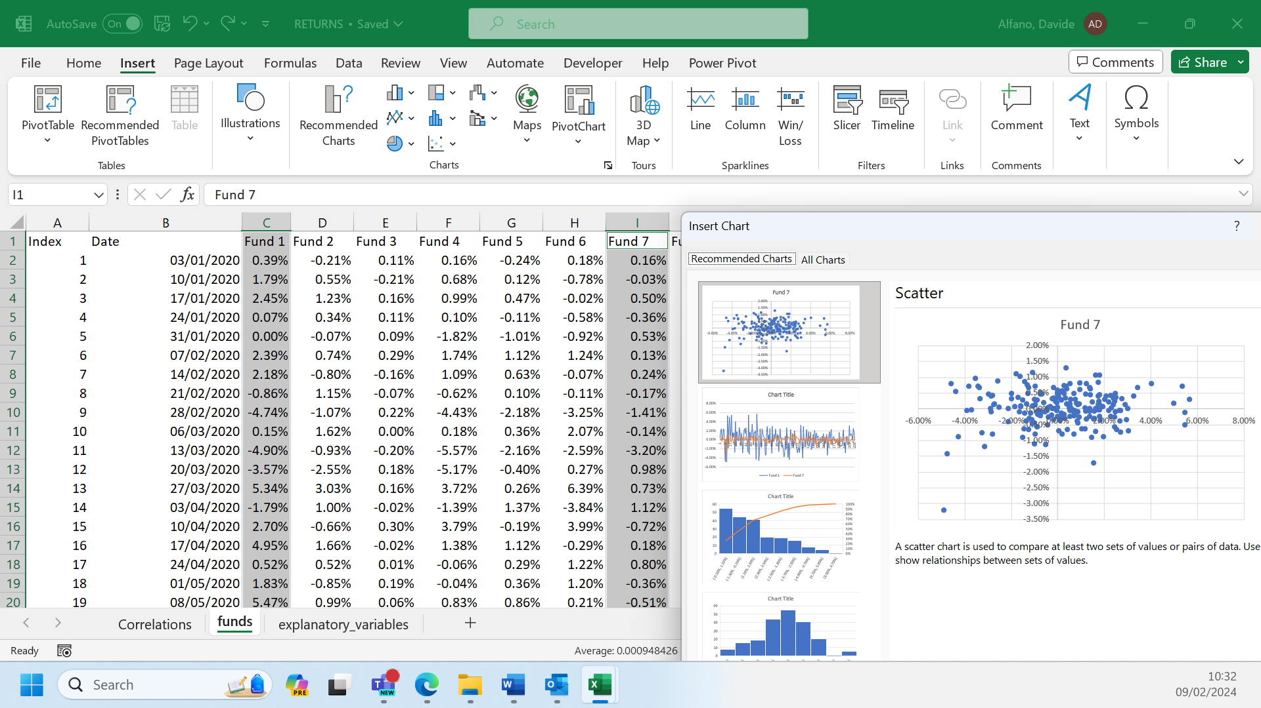

Are the charts confirming the indications obtained from the correlation matrix?

**Task 3**

Create a **histogram** for the returns of funds 1, 2, 3, 4, and 5.

Remember to set the same **number** **of** **bins** in each histogram for a valuable comparison of the same.

The histograms for each of the 5 funds are visualised:

Can you guess what the mean, median, and mode values for the returns of each fund are from their histograms?

Can you identify the funds whose returns are more impacted by outliers?

You might use the Excel function skew() to support your findings. A distribution is considered skewed if it is not symmetrical, meaning it has a longer tail on one side than the other. Skewness can be positive (right-skewed), negative (left-skewed), or zero (symmetrical).



**Task 4**

Use data analysis to calculate a **linear regression** of each fund’s returns (first 5 funds) vs. explanatory variables (available in the file).

This is the output of the regression analysis where the dependent variable is represented by the returns of fund 1 vs. the three explanatory variables in the file.

What is the impact of each explanatory variable on the returns of fund 1?

Is this impact significative (check p values for each coefficient)?

